16 Mar 2021

Hello,

Firstly I attach Loic Salles paper.

Secondly,  here is the graph from Chris Mair’s thesis, I don’t think he has included it in the paper that he has just published (also attached).

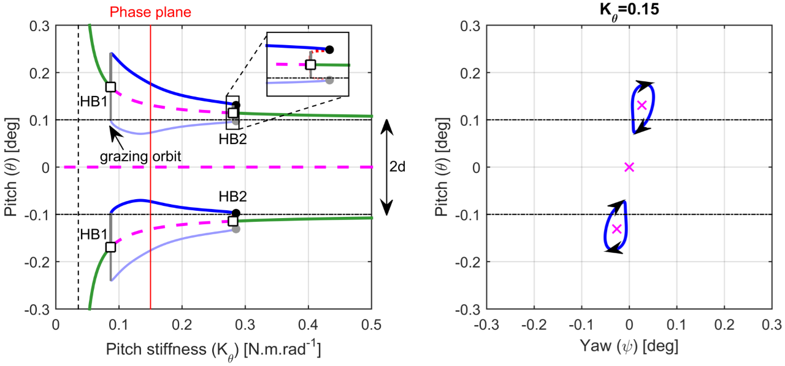

It shows how his Hopf bifurcations manage to bridge up to an amplitude where the orbits graze (ie. move in and out of contact), because the grazing orbits are connected via a grey region of neutrally stable responses.  [the green lines are stable fixed points, the pink dashes unstable fixed points]. I think he is a little fortunate that this occurred for his system, because it means that auto can follow this structure. If the neutrally stable branch wasn’t there, he wouldn’t be able to reach the grazing because it would not be adjacent to the fixed point solution.

We might need some tricks that create these neutrally stable branches (perhaps through the zero damping case?).

Best regards,

Alex

////

Alex,

Thank you for the papers and plots. The bifurcation diagram of Chris Mair does look a bit strange - neutrally stable solutions are quite unusual and I assume the bifurcation diagram would be very sensitive to perturbations in the system, and to disturbances in the excitation.

This looks like an interesting direction - I have some reading to do.

Regards,  
  
Mike